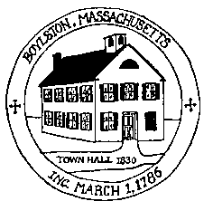
Town of Boylston Planning Board planning@boylston-ma.gov
221 Main Street, Boylston MA 01505 ** Telephone (508) 869-6019 ** Fax (508) 869-6210

AGENDA

JANUARY 12, 2014

7:00 p.m. Compass Pointe

